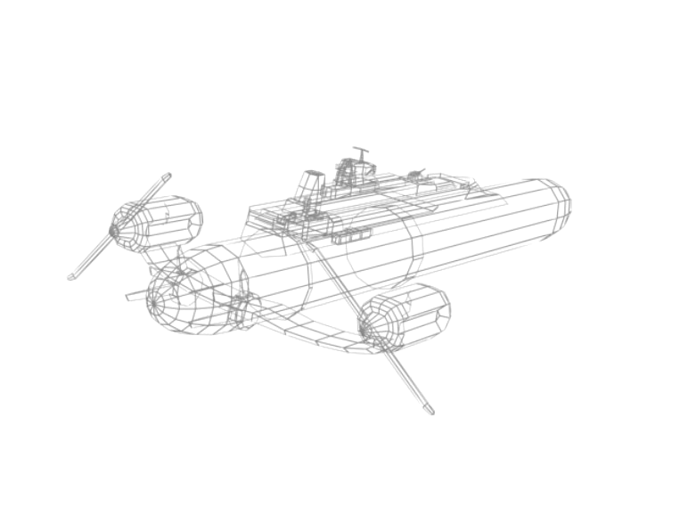
IRON SKIES

User Manual V0.078

Welcome
Welcome to the Nezzu Straits! You have been placed in control of a training vessel to familiarise yourself with tactical aerial combat.

- Your ship is controlled with the keyboard.
- You can move the camera by holding down the right mouse button and moving the mouse.
- In order to fire the many different weapons of an airship easily, they are split into Weapon Groups. You can toggle between weapon groups by pressing the number keys 1-3, then aim and fire by holding down the left mouse button.

You have three weapon groups on the currently issued airship; Group 1 is your Dorsal Cannons; the two on the front. These fire at high speed but take a long time to reload, so are useful for distant targets. Group 2 and 3 are your Left and Right Broadside batteries respectively. These are slow-moving but deadly short-range weapons.
Remember to keep moving to avoid being shot by enemy ships, and stay aware of your surroundings in Command View (0 key) by holding the right mouse button and dragging the mouse.

Controls
Command Control:
Movement | Key
Increase Speed | W
Decrease Speed | S
Turn Airship Left | A
Turn Airship Right | D
All Engines Full | E
All Stop | C
Rise | Shift
Descend | Ctrl
Weapon Group switch (1-3) | 1 to 3
Lock/Unlock Camera rotation to ship | T
Move Camera | Right Mouse Button + Mouse Control
Zoom Camera | Mousewheel +/-
Horn | H
Deploy Practice Target | ALT
Weapon Group Control:
Movement | Key
Command View | 0 (or weapon group key again)
Aim Turret | Mouse Control
Fire | Left Mouse Button
Misc:
Function | Key
Pause | P
Target info toggle switch | Y

